Ch.05.Reactor Kinetics
5.1 Introduction 1
5.2 Neutron Balance Equations 1
5.2.1 Infinite Medium Non-multiplying Systems 1
5.2.2 Infinite Medium Multiplying Systems 1
5.2.3 Finite Multiplying Systems 1
5.3 Multiplying Systems Behavior 1
5.4 Delayed Neutron Kinetics 1
5.4.1 Kinetics Equations 1
5.4.2 Reactivity Formulation 1
5.5 Step Reactivity Changes 1
5.5.1 Reactor Period 1
5.5.2 Prompt Jump Approximation 1
5.5.2.1 Rod Drop 2
5.5.2.2 Source Jerk 2
5.5.2.3 Rod Oscillator 2
5.6 Prologue to Reactor Dynamics 2

Introduction
- Follow dynamics of neutron chain reaction or time behavior.
- We apply two simplifications:
  - Average all cross sections over the energy spectrum of the reactor
  - Apply spatial averaging to neutrons
- To study time kinetic in a simple way, average the other two dimensions and focus on time only now.

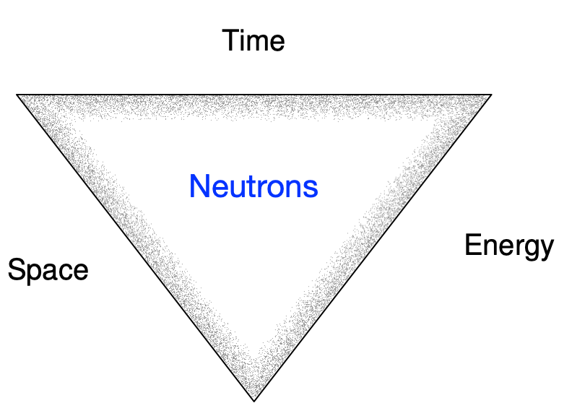

Non multiplying (no fissionable material, ∞)  ↓  Multiplying (i.e., with fissionable material, ∞)  ↓  Multiplying and finite (i.e. with leakage)  ↓  Multiplying + finite + delayed neutrons | 🔲  ↓  fissionable  ↓  Fissionable + boundary  ↓  Fissionable + boundary + delayed neutrons  ↓ | $$n\left(t\right)=n\left(0\right)\exp\left(-\frac{t}{l_{∞}}\right)$$  ↓  $$n\left(t\right)=n\left(0\right)\exp\left(-\frac{k_{∞}-1}{l_{∞}}t\right)$$  ↓  $$n\left(t\right)=n\left(0\right)\exp\left(-\frac{k-1}{l}t\right)$$  ↓  $$n\left(t\right)=n\left(0\right)\exp\left(-\frac{k-1}{\overline{l}}t\right)$$  ↓  $$n\left(t\right)=n\left(0\right)\exp\left(t/T\right)$$ | $$k_{∞}=νΣ_{f}/Σ_{a}$$  $$l_{∞}=1/Σ_{a}\overline{v}$$  $$k=k_{∞}*P_{NL}$$  $$l=l_{∞}*P_{NL}$$  $$\overline{l}=l+β/λ$$

Neutron Balance Equations

Infinite Medium Non-Multiplying Systems
- In infinite non-multiplying medium, the neutron population changes due to either source or absorption:
$$\frac{d}{dt}n\left(t\right)=S\left(t\right)-Σ_{a}\overline{v}n\left(t\right)$$

- At time $t=0$, assume no source ($S(t)=0$) and initial population of $n(0)$:

$$n\left(t\right)=n\left(0\right) exp\left(-t/l_{∞}\right)$$

- The mean “infinite”, lifetime of a neutron is given by:

$$l_{∞}=\frac{\int_{0}^{∞}{tn\left(t\right)dt}}{\int_{0}^{∞}{n\left(t\right)dt}}=\frac{1}{Σ_{a}\overline{v}}$$

- Let us have a constant source on top of absorption:
$$\frac{d}{dt}n\left(t\right)=S\left(t\right)-Σ_{a}\overline{v}n\left(t\right)=S_{0}-Σ_{a}\overline{v}n\left(t\right)=S_{0}-\frac{n\left(t\right)}{l_{∞}}→$$
$$n\left(t\right)=l_{∞}S_{0}\left[1-exp\left(-\frac{t}{l_{∞}}\right)\right]$$
$$\frac{d}{dt}n\left(t\right)=S\left(t\right)+Constant*n\left(t\right)→n\left(t\right)=\left\{\begin{matrix}S\left(t\right)=0 & n\left(t\right)=n\left(0\right)*exp⁡(-t/constant) \\ S\left(t\right)=S_{0} & n\left(t\right)=constant*S_{0}\left[1-\exp\left(-t/constant\right)\right]\end{matrix}\right.$$

Infinite Medium Multiplying Systems
- Add fissionable material on top of a source term and absorption:

$$\frac{d}{dt}n\left(t\right)=S\left(t\right)+{νΣ}_{f}\overline{v}n\left(t\right)-Σ_{a}\overline{v}n\left(t\right)$$

- The infinite multiplication factor has been defined from before to be: $k_{∞}=νΣ_{f}/Σ_{a}$

$$\frac{d}{dt}n\left(t\right)=S\left(t\right)+Σ_{a}\overline{v}n\left(t\right)\left[\frac{{νΣ}_{f}}{Σ_{a}}-1\right]=S\left(t\right)+\frac{n\left(t\right)}{1/Σ_{a}\overline{v}}\left[\frac{{νΣ}_{f}}{Σ_{a}}-1\right]=S\left(t\right)+\frac{n\left(t\right)}{l_{∞}}\left[k_{∞}-1\right]=S\left(t\right)+\frac{k_{∞}-1 }{l_{∞}}n\left(t\right)$$

- So, the changes to the population are the source and whatever difference from unity the infinite multiplication factor gives out (positive or negative):

$$\frac{d}{dt}n\left(t\right)=S\left(t\right)+\frac{k_{∞}-1 }{l_{∞}}n\left(t\right)$$

- If there is no source, the equation simplifies to:

$$\frac{d}{dt}n\left(t\right)=\frac{k_{∞}-1 }{l_{∞}}n\left(t\right): \left\{\begin{aligned}k_{∞}>1 supercritical \\ k_{∞}=1 critical \\ k_{∞}<1 subcritical\end{aligned}\right.$$

$$n\left(t\right)=l_{∞}S_{0}\left[1-exp\left(-\frac{k_{∞}-1}{l_{∞}}t\right)\right]$$

$$n\left(t\right)=n\left(0\right) exp\left(-\frac{k_{∞}-1}{l_{∞}}t\right)$$

Finite Multiplying Systems
- Now, add leakage term and model it to be proportional to the absorption term:

$$\frac{d}{dt}n\left(t\right)=S\left(t\right)+{νΣ}_{f}\overline{v}n\left(t\right)-Σ_{a}\overline{v}n\left(t\right)-{Γ Σ}_{a}\overline{v}n\left(t\right)$$

- You may state that neutrons:
  - Born from:
    - External source $S\left(t\right)$
    - Fission source
  - Die because of:
    - Absorption
    - Leakage from the system
- Thus, the probability of leakage compared to the total losses are:

$$P_{L}=\frac{Γ}{1+Γ}, P_{NL}=\frac{1}{1+Γ}$$
- As noted, the neutrons are removed by either leakage or absorption and thus: $P_{NL}+P_{L}=1$
- Both are less than 1

- Multiply the above equation by the non-leakage term $P_{NL}$:

$$P_{NL}\frac{d}{dt}n\left(t\right)=P_{NL}S\left(t\right)+P_{NL}{νΣ}_{f}\overline{v}n\left(t\right)-P_{NL}\left(Σ_{a}\overline{v}n\left(t\right)+{Γ Σ}_{a}\overline{v}n\left(t\right)\right)$$
$$P_{NL}\frac{d}{dt}n\left(t\right)=P_{NL}S\left(t\right)+P_{NL}{νΣ}_{f}\overline{v}n\left(t\right)+\frac{P_{NL}}{P_{NL}}Σ_{a}\overline{v}n\left(t\right)\frac{d}{dt}n\left(t\right)=P_{NL}S\left(t\right)+\frac{n\left(t\right)}{1/Σ_{a}\overline{v}}\left[P_{NL}\frac{{νΣ}_{f}}{Σ_{a}}-1 \right]=P_{NL}S\left(t\right)+\frac{P_{NL}}{P_{NL}}\frac{n\left(t\right)}{l_{∞}}\left[{P_{NL}k}_{∞}-1\right]=P_{NL}S\left(t\right)+ P_{NL}\frac{{P_{NL}k}_{∞}-1}{{P_{NL}l}_{∞}}n\left(t\right)$$

$$\frac{d}{dt}n\left(t\right)=S\left(t\right)+ \frac{{P_{NL}k}_{∞}-1}{{P_{NL}l}_{∞}}n\left(t\right)=S\left(t\right)+ \frac{k-1}{l}n\left(t\right)$$ | 5.22

- Where, finite life and finite multiplication factor are: $k={P_{NL}k}_{∞}$, $l={P_{NL}l}_{∞}$, both smaller than their infinite counter parts.

Multiplying Systems Behavior

- Assume that there is no source in Equation 5.22 which can be integrated to be:

$$n\left(t\right)=n\left(0\right)\exp\left( \frac{k-1}{l}t\right): \left\{\begin{aligned}k>1 supercritical, \lim_{t→∞}{n(t)}→∞ \\ k=1 critical, \lim_{t→∞}{n(t)}→n\left(0\right) \\ k<1 subcritical, \lim_{t→∞}{n(t)}→0\end{aligned}\right.$$ | 5.24

- Having a constant source (not varying in time $S\left(t\right)=S_{0}$), 5.22 can be integrated to 5.26:

$n\left(t\right)=\frac{l S_{0}}{k-1}\left\{\exp\left( \frac{k-1}{l}t\right)-1\right\}→∞ as t→∞$ for k > 1 | 5.26

$n\left(t\right)=\frac{l S_{0}}{k-1}\left\{1-exp\left( \frac{-\left(1-k\right)}{l}t\right)\right\}→n\left(∞\right)=\frac{l S_{0}}{k-1} for k<1$ | 5.27

$n\left(t\right)=\frac{l S_{0}}{k-1}\left\{1+\frac{k-1}{l}t+\frac{1}{2}\frac{{\left(k-1\right)}^{2}}{l^{2}}t^{2}+…-1\right\}→n\left(∞\right)=S_{0}t for k=1$ | 5.28
- The time progress of neutrons’ population indicates linear increase in time
- Summary equation:

$$n\left(t\right)=\frac{l S_{0}}{k-1}\left\{\exp\left( \frac{k-1}{l}t\right)-1\right\}:\left\{\begin{aligned}k>1 supercritical, \lim_{t→∞}{n\left(t\right)=()\left\{\exp\left(+()t\right)-1\right\}}→∞ \\ k=1 critical, \lim_{t→∞}{n\left(t\right)→S_{0}t }=∞ \\ k<1 subcritical, \lim_{t→∞}{n(t)}→\frac{l S_{0}}{1-k}\end{aligned}\right.$$

- The time progress of neutrons’ population for the two cases of no source or constant source is shown in Figure 5.1

- Stable population is established for two cases only:
  - Critical multiplication ($k=1$) with no source present ($S(t)=0$)
  - Subcritical multiplication ($k<1$) with constant source present ($S(t)=S_{0}$)
- It is very difficult to stabilize the population given the extremely fast time scale as the neutrons’ lifetime is very small in the range of ${10}^{-8}-{10}^{-4}s$. Any small deviation from unity will either exponentially crash the population or increase it and both are not desired for stability.

f[k_, t_] := 1*Exp[(k - 1) t];
d = 1.5;
Plot[{f[1 - d, t], f[1, t], f[1 + d, t]}, {t, 0, 1},
GridLines -> Automatic, PlotRange -> {0, 3}]

d = 1.5;
g[k_, t_] := 2/(k - d)*(Exp[(k - d) t] - 1);
Plot[{g[1 - d, t], g[1, t], g[1 + d, t]}, {t, 0, 1},
GridLines -> Automatic, PlotRange -> {0, 3}]

Delayed Neutron Kinetics
- 99% of neutrons are prompt and 1% is delayed. The ratio is called “delayed neutron fraction” β:

- The delayed neutrons are around 50 types but usually grouped in six characteristic delay times:

$$β=\sum_{i=1}^{6}{β_{i}}, \frac{1}{λ}=\frac{1}{β}\sum_{i=1}^{6}{β_{i}*\frac{1}{λ_{i}}}$$ | 5.31, 5.34

- Modify the lifetime parameter to account for the delay results in much longer lifetime

$$l_{d}=l+\frac{t_{1 /2 }}{\ln\left(2\right)}=l+1/λ$$  $$\overline{l}=\left(1-β\right)l+βl_{d}=\left(1-β\right)l+β(l+\frac{1}{λ})=l+β/λ$$ | 5.35, 5.36

- This modification is significant since: $\frac{β}{λ}≫l$

Kinetics Equations
- Include the effects of the delayed neutrons by dividing the fission term into:
  - Prompt fission with slightly reduced factor of ($1-β$)
  - Delayed neutrons are kind of decay terms of precursor with concentration, C, and half-life $t_{\frac{i1}{2}}$
    - Source: fission is the source (with $β_{i}$ fractions)
    - Sink: decay of the concentration product similar to any exponential decay

$$\frac{d}{dt}n\left(t\right)=S\left(t\right)+\left(1-β\right){νΣ}_{f}\overline{v}n\left(t\right)+\sum_{i}{λ_{i}C_{i}\left(t\right)}-Σ_{a}\overline{v}n\left(t\right)-{Γ Σ}_{a}\overline{v}n\left(t\right)$$ | 5.37

- We obtain the following modified differential equation:
$$\frac{d}{dt}n\left(t\right)=S\left(t\right)+\frac{1}{l}\left[\left(1-β\right)k-1\right] n\left(t\right)+\sum_{i}{λ_{i}C_{i}\left(t\right)}$$ | 5.40
- The time variation of the pre-cursor concentration changes is given by:
$$\frac{d}{dt}C_{i}\left(t\right)=β_{i}\frac{k}{l}n\left(t\right)-λ_{i}C_{i}, i=1, 2,…6$$ | 5.41

- To have stable solution or zero changes in both neutron population, n, and concentration, C:
  - Assume constant source
  - Zero change in population
  - Zero change in concentration of precursors

$$0=S_{0}+\frac{1}{l}\left[\left(1-β\right)k-1\right] n+\sum_{i}{λ_{i}C_{i}}$$ |  |  | 5.42
$$0=β_{i}\frac{k}{l}n-λ_{i}C_{i}, i=1,2,…, 6$$ | 5.43
- We need to divide the situation into having constant source or not
- If there is a constant source, then 5.42 equation simplifies!

$$0=S_{0}+\frac{1}{l}\left[\left(1-β\right)k-1\right] n+\sum_{i}{λ_{i}C_{i}}=S_{0}+\frac{1}{l}\left[\left(1-β\right)k-1\right] n+\frac{k}{l}n\sum_{i}{β_{i}}=S_{0}+\frac{1}{l}\left[\left(1-β\right)k-1\right] n+\frac{β}{l}kn=S_{0}+\frac{k-1}{l} n$$  $$→n=\frac{lS_{0}}{1-k}$$ | 5.44
- To have the neutron population steady and positive, there are two cases:
  - For a constant source $S_{0}≠0$: k must be less than 1 (sub critical)
  - For no source$S_{0}=0$: k must be one or critical to have n non-zero.

- In both cases, the delayed neutrons have no effect on the final stability value of the solution. The time evolution toward stability is different from the stability value.

Reactivity Formulation

- We want to recast the differential equations in terms of two modified parameters: reactivity $ρ$ (small rho), and prompt lifetime $Λ$ (capital lambda):

$$ρ≡\frac{k-1}{k}$$  $$\frac{k_{∞}-1}{k_{∞}}=\frac{νΣ_{f}/Σ_{a}-1}{νΣ_{f}/Σ_{a}}=\frac{νΣ_{f}-Σ_{a}}{νΣ_{f}}=\frac{net}{fission}$$ | ᵨ5.45
- The reactivity can be thought of as the ratio of the net neutron production rate to the neutron production rate due to fission alone
- The prompt generation time is defined as:
$$Λ≡\frac{l}{k}$$ | 5.45

- With the above two definitions the differential equations can be re-expressed in reactivity terms:

$$\frac{d}{dt}n\left(t\right)=S\left(t\right)+\frac{k}{l}*\frac{1}{k}\left[k-1+βk\right] n\left(t\right)+\sum_{i}{λ_{i}C_{i}\left(t\right)}$$  $$\frac{d}{dt}n\left(t\right)=S\left(t\right)+\frac{1}{Λ}\left[ρ+β\right] n\left(t\right)+\sum_{i}{λ_{i}C_{i}\left(t\right)}$$  $$\frac{d}{dt}C_{i}\left(t\right)=β_{i}\frac{n}{Λ}-λ_{i}C_{i}, i=1,2,…6$$ | 5.47  5.48

- Under steady state condition, there are more nuclei emitting neutrons ($C_{i}(t)$) than neutrons ($n(t)$) which simplifies the steady state solution to the following constant with two cases (constant source with rho non-zero) or exponential

$$n=\frac{ΛS_{0}}{\left|ρ\right|}$$

Step Reactivity Changes
- What happens when a step change in reactivity is applied to an initially critical reactor that has been operating at steady state? Perturb, and see?
- The perturbation is small: a fraction of delayed neutron fraction.
- The two curves are the solution to the differential equations 5.47 and 5.48.
  - Nothing dramatic: reasonably slow multiplication of population in 1-2 minutes given the step size increase in reactivity
  - (This timeframe allows some electromechanical control by inserting control rods.)
- Early (at the start) very fast increase (or decrease) followed by slow growth (or decline)
  - The fast increase (or decrease) is due to the prompt neutrons
  - The slow behavior is due to the delayed neutrons
- The behavior can be approximated with a general formula:
$$n\left(t\right)=constant .\exp\left(\frac{t}{T}\right)=constant .\exp\left(ωt\right)$$
- T is called the period, or the reactor characteristic time if you like,
- T is time required for the reactor power to increase or decrease by a factor of e and is arguably the most important quantity derivable from the kinetics equations.

Reactor Period
- In the following, we try to find the reactor period based on the basic differential equations governing neutrons including delayed fraction:

# | Step | Equation
1 | Assume neutron population and pre-cursors to be in exponential forms  $A, B_{i}and ω$ are assumed constants  (not the solution only form!) | ---  $$\frac{d}{dt}n\left(t\right)=S\left(t\right)+\frac{1}{Λ}\left[ρ+β\right] n\left(t\right)+\sum_{i}{λ_{i}C_{i}\left(t\right)}$$  $$\frac{d}{dt}C_{i}\left(t\right)=β_{i}\frac{n}{Λ}-λ_{i}C_{i}, i=1,2,…6$$ | 5.47  5.48
2 | 7 (1+6) differential equations 5.47 and 5.48  Have the following solutions | $$ωA=\frac{ρ-β}{Λ}A+\sum_{i}{λ_{i}B_{i}}$$  $$ωB_{i}=\frac{β_{i}}{Λ}A+λ_{i}B_{i}$$ | 5.49  5.50
3 | Using the above equations and the beta cross section ($β=\sum_{i=1}^{6}{β_{i}}$) | $$ωA=\frac{ρ-β}{Λ}A+\frac{A}{Λ}\sum_{i}{\frac{λ_{i}β_{i}}{ω+λ_{i}}}$$  $$ω=\frac{ρ-β*1}{Λ}+\frac{1}{Λ}\sum_{i}{\frac{β_{i} λ_{i}}{ω+λ_{i}}}=\frac{ρ}{Λ}-\frac{1}{Λ}\sum_{i}{\frac{β_{i} \left(ω+λ_{i}\right)}{\left(ω+λ_{i}\right)}}+\frac{1}{Λ}\sum_{i}{\frac{β_{i} λ_{i}}{ω+λ_{i}}}=\frac{ρ}{Λ}+\frac{1}{Λ}\sum_{i}{\frac{{-β}_{i} \left(ω+λ_{i}\right){+β}_{i} λ_{i}}{\left(ω+λ_{i}\right)}}=\frac{ρ}{Λ}+\frac{1}{Λ}\sum_{i}{\frac{{-β}_{i} \left(ω\right)}{\left(ω+λ_{i}\right)}}$$  $$ω=\frac{ρ}{Λ}-\frac{1}{Λ}\sum_{i}{\frac{β_{i} }{ω+λ_{i}}}ω$$ | 5.51  5.52
4 | Rearrange the last equation to find reactivity:  “inhour” equation  Reactivity is function of a single prompt term and 6 delayed terms | $$ρ=\left(Λ+\sum_{i}{\frac{β_{i} }{ω+λ_{i}}}\right)ω$$  If there are no delayed neutrons (i.e., $β_{i}=0)$:  $$ρ=Λω→ρT=\frac{l}{k}→T=\frac{l}{kρ}=\frac{l}{k(k-1)/k}=\frac{l}{k-1}$$ | 5.53
5 | The plot of RHS of the inhour equation gives the following figure ($ρ=f\left(ω\right)$)  There are 7 roots for any selected $ρ$ value including $ρ=0$.  Since, the reactivity is desired to be zero, there are only specific values of $ω$ that satisfies this criterion.
 | Plotting a simple example | $y(x)=\left(1-\frac{2}{x+4}-\frac{2}{x+6}\right)x$  $$y=0→x=\left\{0, -3-\sqrt{5},-3+\sqrt{5}\right\}=\{0, -5.2, -0.8\}$$
6 | We must have the neutron population in the following form  $$ω_{1}>ω_{2}>ω_{3}>ω_{4}>ω_{5}>ω_{6}>ω_{7}$$ | $$n\left(t\right)=\sum_{i=1}^{7}{A_{i}\exp{{(ω}_{i}t)}}$$
7 | One term dominates the longtime thus others are dropped: | $$n\left(t\right)≈A_{1}\exp{{(ω}_{1}t)}=A_{1}\exp{(t/T)}$$ | 5.55
8 | When the reactivity is small, so is the largest value of omega,$ω_{1}$. This enables us to remove multiple terms and keep one in reactivity:  asymptotic solution | $$ρ=\left(Λ+\sum_{i}{\frac{β_{i} }{ω+λ_{i}}}\right)ω→\left(Λ+\sum_{i}{\frac{β_{i} }{λ_{i}}}\right)ω_{1}=\left(Λ+\frac{β}{λ}\right)ω_{1}$$
 | “Thus, for small reactivities—positive or negative—the reactor period is governed almost completely by the delayed neutron properties $β$and $λ$.” | Since $Λ≪ β/λ$:  $$ρ=\frac{β}{λ}ω_{1}=\frac{β}{λ}\frac{1}{T} →$$  $$T≈\frac{β}{λρ}$$  So, for small reactivity, $ρ≤± β$, the reactor period is governed by a time constant totally controlled by delayed neutrons. The period is in order of minutes which can be controlled by electromechanical means.
 | Above prompt critical,  $ρ>β$, the period is very small. | $$T≈\frac{Λ}{ρ-β}$$  So, the reactor is extremely sensitive and potentially explosive  If you jerk the reactivity by large amount, $ρ>β$ , the output multiplies in a period comparable to milliseconds!  Prompt criticality is not forgiving, and output of the reactor can multiply to explosive levels.
 | Reactivity measured in $. | $$\$=\frac{ρ}{β}$$

Prompt Jump Approximation

Rod Drop
- Rod drop is a reactivity perturbation method
- Masterson: A study of the transient response of the reactor to a rapid insertion of high negative reactivity
  - dropping the reactor control rods when the reactor is in a critical state
  - immediately after control rod insertion $ρ_{1}=0$ which allows estimating reactivity

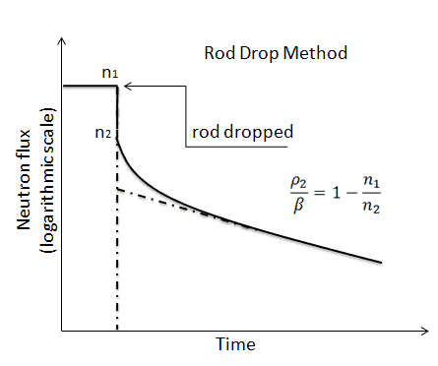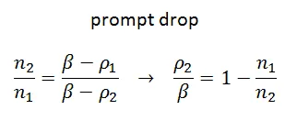

- Lewis: from steady state Immediately following the rod insertion
  - In the immediate time after the rod drop and much less than decay of precursor:

- A solution to this equation can be proven to be, $n\left(0\right)=n_{0}$:

- In some time above the prompt regeneration time and less the decay :

- The reactivity drop in units of beta or $, can be found:
- This is an experimental method to measure the reactor’s reactivity if the perturbation is within a small fraction of beta (i.e. small even compared to delayed fraction):

Source Jerk
- The source jerk is performed on a subcritical reactor,$ρ=-\left|ρ\right|$, containing a neutron source $S_{o}$.
- Removing the source from a subcritical system with reactivity $ρ=-\left|ρ\right|$, (the source jerk experiment) results in a measurable drop in the neutron population from $n_{o} to n_{1}$.

Rod Oscillator
- Another experimental method to measure the reactor’s reactivity is to oscillate the control rod:
- After early transients, the population is stated:

- plotting $\overline{n}/n_{0}$ versus frequency determines $ρ_{0}/Λ$, the ratio of reactivity to prompt neutron generation time

Prologue to Reactor Dynamics
- The analysis so far does not include thermal feed back effects. It is basic and is called “zero-power kinetics.”
- As temperature changes:
  - Density changes
  - Cross sections change
  - Doppler broadening increases
  - Maxwell distribution of neutrons’ energy shifts (harder spectrum for hotter values)
- Temperature feedback could be positive or negative (we desire negative feedback)

- The following figure (log y scale) shows that negative feedback is desired to control overpower.

- Sun’s core as a fusion reactor has negative feedback:
  - As temperature rises, the core expands and rate of fusion decreases
  - As temperature cools, the gravity densifies the core and fusion rate increases

Problems

$$l_{∞}=\frac{1}{Σ_{a}\overline{v}}=\frac{1}{2.2×{10}^{5}cm s^{-1}×0.273×{10}^{-3} {cm}^{-1}}=0.01665 s=17. mS$$

The average velocity change with KE:
$$KE=\frac{1}{2}m v^{2}→\overline{v}∝\sqrt{E}$$
$${\overline{v}}_{2}={\overline{v}}_{1}*\sqrt{\frac{E_{2}}{E_{1}}}=2.2×{10}^{5}cm s^{-1}*\sqrt{\frac{{10}^{6}eV}{0.0253 eV}}=1.38×{10}^{9}cm/s$$

$$l_{∞}=\frac{1}{Σ_{a}\overline{v}}=\frac{1}{1.38×{10}^{9}cm s^{-1}×0.738×{10}^{-3} {cm}^{-1}}=9.82*{10}^{-7}s=0.982 μS$$

- Finding the desired period of the reactor:
$$n\left(t\right)=n\left(0\right)\exp\left(-\frac{k-1}{l}t\right)=n\left(0\right)\exp\left(-t/T\right)$$
$$\frac{n\left(t\right)}{n\left(0\right)}=3=\exp\left(-\frac{t}{T}\right)→\frac{T}{t}=\frac{1}{\ln{3}}→T=\frac{10s}{\ln{3}}=9.1 S$$

- Finding the needed reactivity to achieve the above period:

$$n\left(t\right)=n\left(0\right)\exp\left(-\frac{k-1}{l}t\right)=n\left(0\right)\exp\left(-\frac{ρ}{Λ}t\right)$$
$$\ln\left(\frac{n\left(t\right)}{n\left(0\right)}\right)=-\frac{k-1}{l}t$$
$$\ln\left(3\right)=-\frac{k-1}{0.002s}10s$$
$$k=1+\frac{0.002*\ln{3}}{10}=\left(1.000219722\right)=1.000220$$
$$ρ=\frac{k-1}{k}=\left(0.000219674\right)=0.000220$$

- Period is found using the generic definition of reactor period:

$$n\left(t\right)=n\left(0\right)\exp\left(-\frac{k-1}{l}t\right)=n\left(0\right)\exp\left(-t/T\right)$$
$$\frac{n\left(t\right)}{n\left(0\right)}={10}^{3}=\exp\left(-\frac{t}{T}\right)→\frac{T}{t}=\frac{1}{\ln{3}}→T=\frac{t}{\ln\left(\frac{n}{n_{0}}\right)}=\frac{2hr}{\ln\left({10}^{3}\right)}=0.2895 hr=17.4 m$$

- Since the reactivity is done slowly (cents), we could use the approximate formula:

$$T≈\frac{β}{λ ρ}→\frac{ρ}{β}=\frac{1}{λ T}=\frac{1}{λ \left(17.4*60 s\right)}=\frac{1}{0.0766 s^{-1}*\left(17.4*60 s\right)}=0.0125046\$=1.25 ¢$$

Let us assume that we are dealing with U-235 and obtain the beta and lambda from Table 5.1:
$$\frac{1}{λ}=\frac{1}{β}*\sum{\frac{β_{i}}{λ_{i}}}$$
$$λ_{i}=\frac{\log{2}}{T_{\frac{1}{2},i}}$$
$$λ=0.766 s^{-1}$$

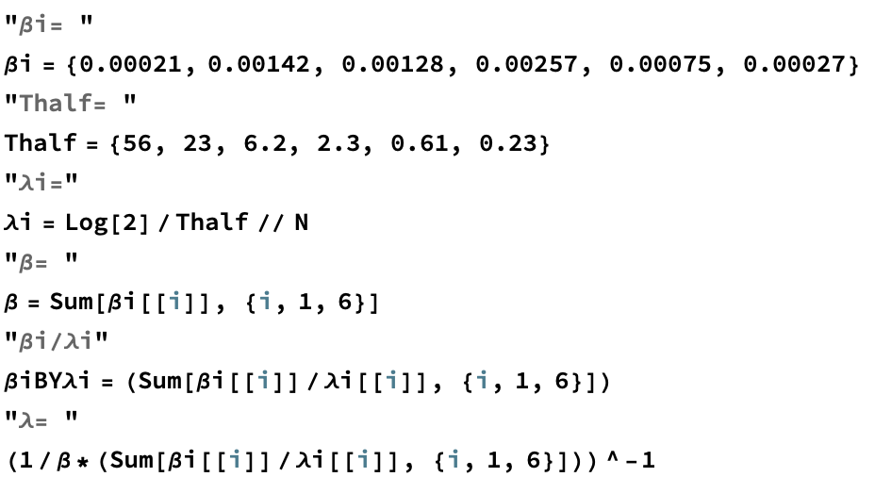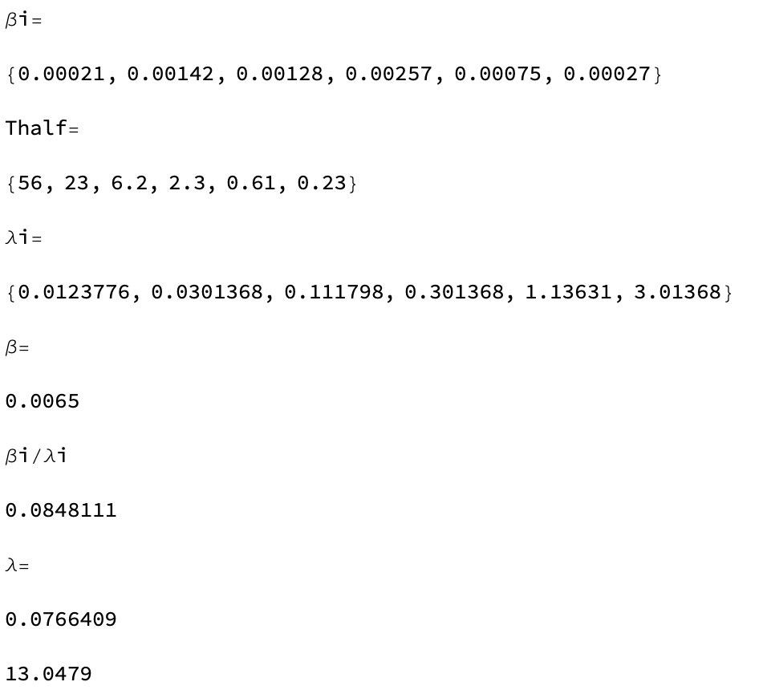

We had computed decay constant for U-235:

$$λ=0.766 s^{-1}$$
$$T≈\frac{β}{λ ρ}=\frac{β}{ ρ}\frac{1}{λ}=\frac{β}{+0.01β*}\frac{1}{0.766 s^{-1}}=1305.48S\frac{m}{60S}=21.8 m$$

$$T≈\frac{β}{λ ρ}=\frac{β}{ ρ}\frac{1}{λ}=\frac{β}{-0.01β*}\frac{1}{0.766 s^{-1}}=-1305.48S\frac{m}{60S}=-21.8 m$$

$$\frac{\left|ρ\right|}{β}=\frac{n_{0}}{n_{1}}-1=\frac{80}{60}-1=0.33\$$$

$\frac{dN\left(t\right)}{dt}=A_{0}-λN\left(t\right)→λN\left(t\right)=A_{0}\left(1-e^{-λt}\right) \left(as in Chapter 1.5 assuming N\left(0\right)=0\right)$

